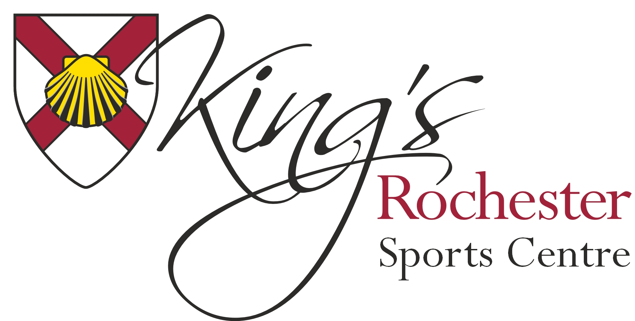
Job title: Casual Bar Staff
Zero Hours Contract
Location: King’s Rochester Sports Centre
Rate of pay: Minimum wage - £6.70per hour (depending on experience)
Responsible to: Sports Centre Manager
Primary purpose of job: To serve the public working behind the bar during parties, functions and conferences. Food prep and food service with some cooking.
Person Specification: At Kings Rochester Sports Centre are always on the lookout for great staff to help us improve. We are currently recruiting for casual Bar staff to work in our function bar on Fridays, Saturdays and Sundays. The role is very demanding and requires a person who has good customer service skills and qualities. You must be prepared to work under pressure in a busy bar.
Previous bar experience is desirable and the ability to cook would be an advantage; a willingness to learn is essential. This role is not suitable for anyone under the age of 18 years.
Method of Application
To apply for this position please complete an application form and return to Deny Wilson, General Manager, King’s Rochester Sports Centre, 601 Maidstone Road, Rochester, Kent ME1 3QJ, or by email to dwilson@kingssportscentre.co.uk

