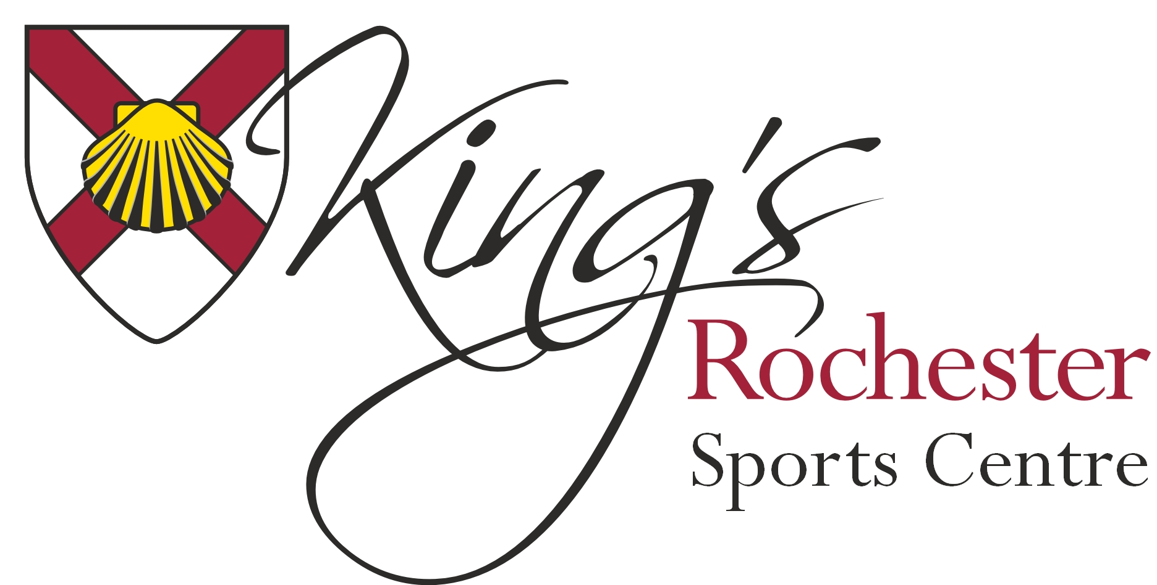
Job title: Multi Sports Coach
Zero Hours Contract
Location: King’s Rochester Sports Centre
Rate of pay: £6.00 - £15.00 per hour (depending on qualifications & experience)
Responsible to: Sports Centre Manager
Primary purpose of job: To deliver quality coaching sessions to young people attending the holiday club at the Kings Rochester Sports Centre. To ensure excellent standards are maintained in a pleasant, safe and healthy environment for all users of the Centre.
Person Specification: At Kings Rochester Sports Centre are always on the lookout for new staff to help us make our holiday club great. If you are looking for a job during the school breaks and think you have what it takes then get in touch as we’d love to hear from you!
Working on our holiday club is a great way to earn some money, gain some great experience and have fun along the way. Whether you want the odd days’ work here and there or want a full week during each school break we have a lot of opportunities for you.
We are looking for enthusiastic coaches who love working with children and who would get a kick out of giving the children the best possible Sport experiences during their time with us. Positions vary from Head Coaches, Coaches, Dance instructors, Specialist sports coaches and Multi Activity co-coordinators.
The ideal candidate will have a Recognised NGB Level 2 Coaching Certificate or above, Experience and knowledge of working with children and young people, Able to pass an Enhanced DBS Check and be deemed safe to work with children. A passion for Sport and working with children is essential.
Method of Application
To apply for this position please complete an application form and return to Deny Wilson, General Manager, King’s Rochester Sports Centre, 601 Maidstone Road, Rochester, Kent ME1 3QJ, or by email to dwilson@kingssportscentre.co.uk

